Neo4j Project

GMIT Timetable

James O’Hanlon

Student Id: G00318662

Lecturer: Ian McLoughln

Introduction

As part of my course in 3rd year software development, we were required to create a reconstruction of our class timetable using a graph database software application called Neo4j.

The goal of the project was to figure out from our timetable, what should be a node, property, label, and create relationships.

What is Neo4j?

Neo4j is a free graph database management system developed by Neo Technology, Inc. According to db-engines.com, it is the most popular graph database and is described by its developers as an ACID-comliant transactional database with native storage and processing.

System Requirements

System requirements to run Neo4j.

* Minimum – Intel Core i3 (Intel Core i7 recommended)
* Minimum 2GB of RAM(16-32GB or more recommended)
* 4 GB of available hard disk space.
* 10GB hard disk drive.
* Neo4j requires a Java Virtual Machine, JVM, to operate.

My project: How I created my Timetable using Neo4j.

Brainstorming

The first step I took for my project was looking up my timetable and figuring out the best possible way to design my graph, I got out a piece of paper and worked out what where nodes, properties and if they need to be labelled. Then I created relationships between them.

GitHub

Once I had a rough idea of my graph, I created a Github repository so I could save and keep track of my work.

GitHub name/Repository name: Jomzi/TimeTableGraphTheory

Neo4j

Getting the project started I downloaded Neo4j. Then ran it and created a database called Timetable. Once I had the Neo4j template in front of me I got out the piece of paper to figure out what goes where. I also looked up examples of other Neo4j databases and the movie database that you get when you download Neo4j, this gave me an insight of where to start. A lot of my designing was trial and error. I used different sites to learn cypher querying.

Testing

Testing my project, I ran my saved database from Neo4j and open it in a local host browser.

References

To get information and help for my Neo4j project I mainly used the following sites:

Youtube

Neo4j

StackoverFlow

LearnOnline

Screenshots

Rough drawing of how I wanted my graph to work and be designed

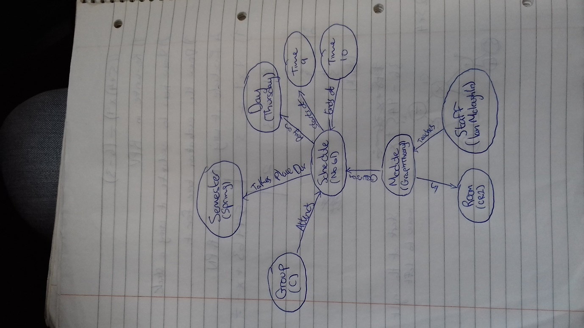

Running a query in Neo4j

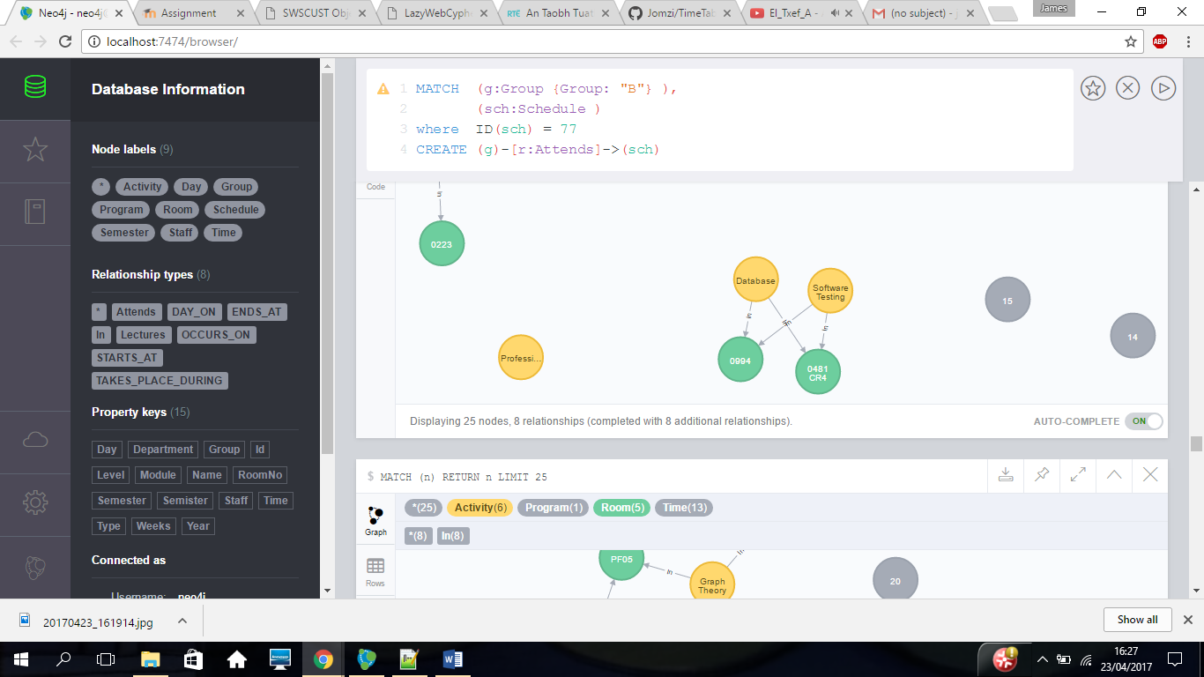

Here is a good scrrenshot to understand how everything is linked!

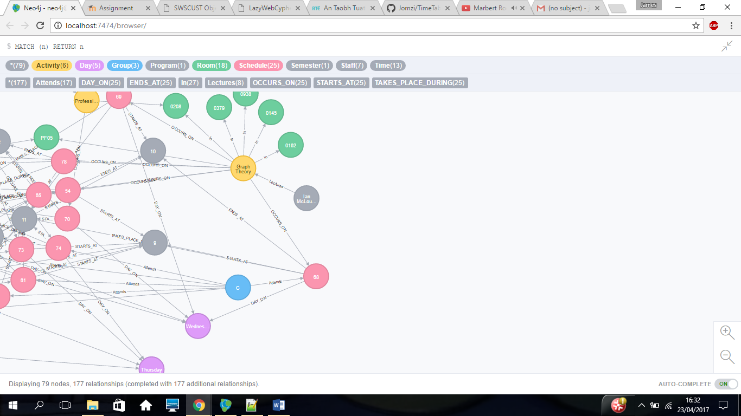

Final Graph finished and working

